

**MVPS’s**

**RAJARSHI SHAHU MAHARAJ POLYTECHNIC,**

**NASIK**

**SUBJECT**

**Environmental Studies (22447)**

**MICRO-PROJECT ON**

**“A Report on Sources of Energy”**

**Submitted By**

|  |  |  |  |
| --- | --- | --- | --- |
| **SR.**  **NO.** | **ENROLLMENT NO.** | **EXAM SEAT NO.** | **STUDENT NAME** |
| 1 | 1910020362 | 215646 | SAVANT OMKAR VITTHAL |
| 2 | 1910020363 | 215647 | SAWANT DIKSHA PRAVIN |
| 3 | 1910020364 | 215648 | SHIMPI OM VILAS |

**Guided By**

Mr. G. N. Handge

**COMPUTER TECHNOLOGY DEPARTMENT**

**ACADEMIC YEAR 2021-22**

# Certificate

This is to certify that Mr. /Ms. ___Omkar Vitthal Savant__________________ Roll No.:- _46__ of Fifth Semester of Diploma in Computer Technology **(CM-5-I)** of Institute **M.V.P.S’s** **RAJARSHI SHAHU MAHARAJ POLYTECHNIC, NASHIK-13, (InstituteCode-1002)** has successfully completed the Micro Project on “___A Report on Sources of Energy _______” in the course **Environmental Studies** **(22447)** for the academic year 2021-22 as prescribed in curriculum of MSBTE, Mumbai.

|  |  |
| --- | --- |
| **Place:- Nashik** | **Enrollment No.:-** |
| **Date:-** | **Exam Seat No.:-** |

|  |  |  |
| --- | --- | --- |
| **Mr. G. N. Handge** | **Mr. P. D. Boraste** | **Dr. D. B. Uphade** |
| **Course Teacher/Guide** | **H.O.D** | **Principal** |

Seal of

Institute

**Abstract**

This paper scrutinizes the use of different concepts of Environmental Studies subject, enabling viewer to get the complete concept of different aspects of Environment. There are various sources of energy from renewable to non-renewable sources. To satisfy the need of environmental education we have created a report on various sources of energy.

**INDEX**

|  |  |  |
| --- | --- | --- |
| **Sr.**  **No.** | **Chapter Name** | **Page**  **No.** |
| 1 | Introduction | 5 |
| 2 | Renewable Energy | 8 |
| 3 | Non-Renewable Energy | 10 |
| 4 | Advantages | 12 |
| 5 | Disadvantages | 19 |
| 6 | Conclusion | 25 |
| 7 | References | 26 |

**Chapter-1**

**INTRODUCTION**

## Energy:

In physics, energy is the quantitative property that must be transferred to a body or physical system to perform work on the body, or to heat it. Energy is a conserved quantity; the law of conservation of energy states that energy can be converted in form, but not created or destroyed. The unit of measurement in the International System of Units (SI) of energy is the joule, which is the energy transferred to an object by the work of moving it a distance of one metre against a force of one newton.

Common forms of energy include the kinetic energy of a moving object, the potential energy stored by an object's position in a force field (gravitational, electric or magnetic), the elastic energy stored by stretching solid objects, the chemical energy released when a fuel burns, the radiant energy carried by light, and the thermal energy due to an object's temperature.

Living organisms require energy to stay alive, such as the energy humans get from food and oxygen. Human civilization requires energy to function, which it gets from energy resources such as fossil fuels, nuclear fuel, or renewable energy. The processes of Earth's climate and ecosystem are driven by the radiant energy Earth receives from the Sun and the geothermal energy contained within the earth.

The Sun is the ultimate source of energy for most of life on Earth.It derives its energy mainly from nuclear fusion in its core, converting mass to energy as protons are combined to form helium. This energy is transported to the sun's surface and released into space (mainly in the form of radiant (light) energy).

Fig.1. Sun is the ultimate source of energy

## Forms of Energy:

The total energy of a system can be subdivided and classified into potential energy, kinetic energy, or combinations of the two in various ways. Kinetic energy is determined by the movement of an object – or the composite motion of the components of an object – and potential energy reflects the potential of an object to have motion, and generally is a function of the position of an object within a field or may be stored in the field itself.

While these two categories are sufficient to describe all forms of energy, it is often convenient to refer to particular combinations of potential and kinetic energy as its own form. For example, the sum of translational and rotational kinetic and potential energy within a system is referred to as mechanical energy, whereas nuclear energy refers to the combined potentials within an atomic nucleus from either the nuclear force or the weak force, among other examples

|  |  |
| --- | --- |
| **Some forms of energy (that an object or system can have as a measurable property)** | |
| **Type of energy** | **Description** |
| [Mechanical](https://en.wikipedia.org/wiki/Mechanical_energy) | the sum of [macroscopic](https://en.wikipedia.org/wiki/Macroscopic) translational and rotational kinetic and potential energies |
| [Electric](https://en.wikipedia.org/wiki/Electrical_energy) | potential energy due to or stored in electric fields |
| [Magnetic](https://en.wikipedia.org/wiki/Magnetic_energy) | potential energy due to or stored in magnetic fields |
| [Gravitational](https://en.wikipedia.org/wiki/Gravitational_energy) | potential energy due to or stored in gravitational fields |
| [Chemical](https://en.wikipedia.org/wiki/Chemical_energy) | potential energy due to chemical bonds |
| [Nuclear](https://en.wikipedia.org/wiki/Nuclear_binding_energy) | potential energy that [binds](https://en.wikipedia.org/wiki/Binding_energy) [nucleons](https://en.wikipedia.org/wiki/Nucleons) to form the [atomic nucleus](https://en.wikipedia.org/wiki/Atomic_nucleus) (and nuclear reactions) |

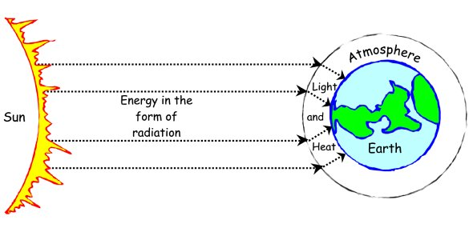

Fig.3. Solar Energy

Fig.4. Types of Energy

# Chapter-2

# RENEWABLE ENERGY

Renewable energy is energy that is collected from renewable resources that are naturally replenished on a human timescale. It includes sources such as sunlight, wind, rain, tides, waves, and geothermal heat. Renewable energy stands in contrast to fossil fuels, which are being used far more quickly than they are being replenished. Although most renewable energy sources are sustainable, some are not. For example, some biomass sources are considered unsustainable at current rates of exploitation.

Renewable energy often provides energy in four important areas: electricity generation, air and water heating/cooling, transportation, and rural (off-grid) energy services. About 20% of humans' global energy consumption is renewables, including almost 30% of electricity. About 8% of energy consumption is traditional biomass, but this is declining. Over 4% of energy consumption is heat energy from modern renewables, such as solar water heating, and over 6% electricity.

While many renewable energy projects are large-scale, renewable technologies are also suited to rural and remote areas and developing countries, where energy is often crucial in human development. As most of renewable energy technologies provide electricity, renewable energy is often deployed together with further electrification, which has several benefits: electricity can be converted to heat, can be converted into mechanical energy with high efficiency, and is clean at the point of consumption. In addition, electrification with renewable energy is more efficient and therefore leads to significant reductions in primary energy requirements. In 2021 China accounted for almost half of

the increase in renewable electricity.

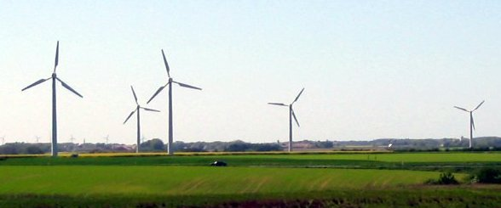

Fig.5. Windmill – Sustainable Energy

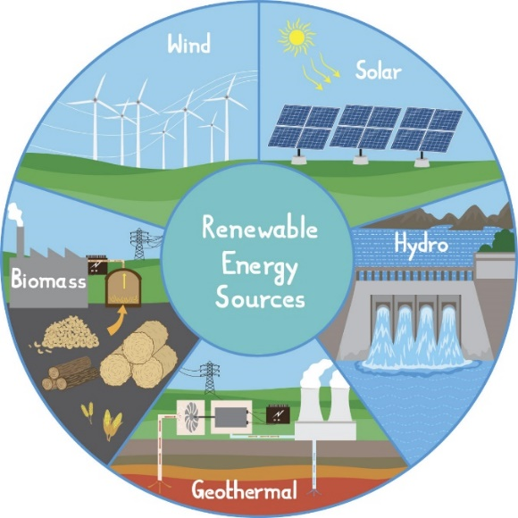

Fig.6. Renewable Energy – I

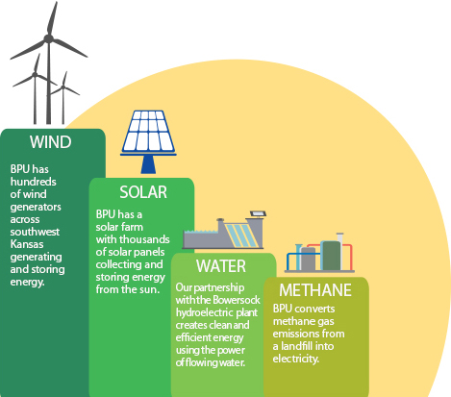

Fig.7. Renewable Energy – II

# Chapter-3

# NON -RENEWABLE ENERGY

A non-renewable resource (also called a finite resource) is a natural resource that cannot be readily replaced by natural means at a pace quick enough to keep up with consumption.

An example is carbon-based fossil fuels. The original organic matter, with the aid of heat and pressure, becomes a fuel such as oil or gas. Earth minerals and metal ores, fossil fuels (coal, petroleum, natural gas) and groundwater in certain aquifers are all considered non-renewable resources, though individual elements are always conserved (except in nuclear reactions, nuclear decay or atmospheric escape).

Conversely, resources such as timber (when harvested sustainably) and wind (used to power energy conversion systems) are considered renewable resources, largely because their localized replenishment can occur within time frames meaningful to humans as well.

Nonrenewable resources come from the Earth. Humans extract them in gas, liquid, or solid form and then convert them for their use, mainly related to energy. The reserves of these substances took billions of years to form, and it will take billions of years to replace the supplies used.

Examples of nonrenewable resources include crude oil, natural gas, coal, and uranium. These are all resources that are processed into products that can be used commercially.

Fig.8. Coal Mining

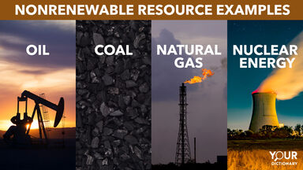

Fig.9. Non-Renewable Energy – I

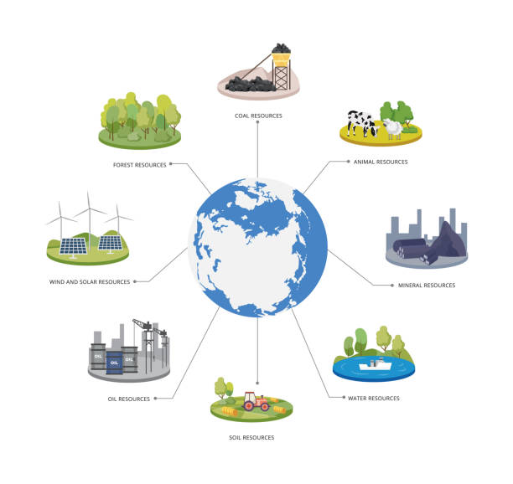

**Fig.10. Non-Renewable Energy – II**

# Chapter-4

# ADVANTAGES

# Renewable Energy:

# Renewable energy won’t run out

# Renewable energy has lower maintenance requirements

# Renewables save money

# Renewable energy has numerous environmental benefits

# Renewables lower reliance on foreign energy sources

# Renewable energy leads to cleaner water and air

# Renewable energy creates jobs

# Renewable energy can cut down on waste

# 1. Renewable energy won’t run out

# Renewable energy technologies use resources straight from the environment to generate power. These energy sources include sunshine, wind, tides, and biomass, to name some of the more popular options. Renewable resources won’t run out, which cannot be said for many types of fossil fuels – as we use fossil fuel resources, they will be increasingly difficult to obtain, likely driving up both the cost and environmental impact of extraction.

# 2. Maintenance requirements are lower for renewable energy

# In most cases, renewable energy technologies require less overall maintenance than generators that use traditional fuel sources. This is because generating technology like solar panels and wind turbines either have few or no moving parts and don’t rely on flammable, combustible

# fuel sources to operate. Fewer maintenance requirements translate to more time and money saved.

# 3. Renewables save money

# Using renewable energy can help you save money long term. Not only will you save on maintenance costs, but on operating costs as well. When you’re using a technology that generates power from the sun, wind, steam, or natural processes, you don’t have to pay to refuel. The amount of money you will save using renewable energy can vary depending on a number of factors, including the technology itself. In most cases, transitioning to renewable energy means anywhere from hundreds to thousands of dollars in savings—find out how much you can save by switching to solar energy.

# 4. Renewable energy has numerous environmental benefits

# Renewable energy generation sources emit little to no greenhouse gases or pollutants into the air. This means a smaller carbon footprint and an overall positive impact on the natural environment. During the combustion process, fossil fuels emit high amounts of greenhouse gases, which have been proven to exacerbate the rise of global temperatures and frequency of extreme weather events.

# The use of fossil fuels not only emits greenhouse gases but other harmful pollutants as well that lead to respiratory and cardiac health issues. With renewable energy, you’re helping decrease the prevalence of these pollutants and contributing to an overall healthier atmosphere.

# 5. Renewables lower reliance on foreign energy sources

# With renewable energy technologies, you can produce energy locally. The more renewable energy you’re using for your power needs, the less you’ll rely on imported energy, and the more you’ll contribute to U.S. energy independence as a whole. Renewable energy sources can help us minimize the geo-political risks associated with fossil fuels, from trade disputes to political instability to pricing wars, all of which are often rooted in access to oil.

# 6. Renewable energy leads to cleaner water and air

# When you burn fossil fuels to generate electricity, it contaminates the air and water we use. For example, coal power stations release high volumes of carbon dioxide and nitrous oxide, as well as harmful toxins like mercury, lead, and sulfur dioxide. Health problems from ingesting these elements can be dangerous, and even fatal in some cases. Investing in renewable energy is a great way to work against these risks, as renewables have a far lower negative impact on our air and water.

# The use of fossil fuels not only emits greenhouse gases but other harmful pollutants as well that lead to respiratory and cardiac health issues. With renewable energy, you’re helping decrease the prevalence of these pollutants and contributing to an overall healthier environment.

# 7. Renewable energy creates new jobs

# While the U.S. shifts its focus to combat global warming, we’re setting ambitious carbon-reduction goals that require labor to get the job done. Today, the renewable energy sector employs three times as many people as fossil fuels do in the U.S. That number is expected to rise over the next few years—and as a plus, these jobs tend to pay above average wages, making it a very attractive career option and an overall economic boom.

# 8. Renewable energy can help solve our waste problem

# Specifically, biomass energy can offer a big benefit in this way. Biomass generators consume used organic products like vegetable oil, corn and soybean byproducts, and even algae to generate energy. Because of this, using biomass as an energy source can reduce the amount of waste that goes into landfills, which helps cut down on carbon emissions and environmental contamination.

# Non-Renewable Energy:

# We can prepare non-renewable supplies at almost any location.

# Non-renewables produce more power after the refinement process.

# Thousands of unique products come from non-renewables.

# The global economy depends on the presence of non-renewables.

# Non-renewable energy provides a stronger energy output.

# It is cheaper to obtain non-renewable energy that other resources.

# Non-renewable energy provides us with many of the tools we use every day.

# Our current infrastructure was built specifically for non-renewable energy.

# 1. We can prepare non-renewable supplies at almost any location.

# If we want to control energy from renewables, then we must identify regions globally that support this outcome. This issue applies to solar, wind, and even geothermal for some geographic locations. Some locations are not well-suited to the production of renewable energy.

# It is not an issue for non-renewables because we can develop processing stations everywhere to establish their refinement and distillation. Although problems with transport loss occur when using them, a well-developed infrastructure can reduce this predicament rather effectively.

# 2. Non-renewables produce more power after the refinement process.

# When we process non-renewables to seize the energy potential offered, we can generate more power from crude oil, natural gas, and other fuels than what they provide in their raw format.

# If we take a single barrel of crude oil, then it provides 42 gallons of product to use at our discretion. When we complete the work of preparing this non-renewable, then the yield gives us the equivalent of more than 44 gallons of finished products. That means we attain 6% more energy potential when using fossil fuels, and that’s a total that renewables can’t replicate.

# 3. Thousands of unique products come from non-renewables.

# We can refine the hydrocarbons found in fossil fuels to create numerous products that we use every day. Thousands of different items are possible thanks to this advantage of the non-renewables industry. Plastics, soaps, and many more items make it possible to live a modern lifestyle at an affordable price because of this resource. Many of the safety products we’ve developed over the past several decades are directly related to improvements in hydrocarbon refinement.

# 4. The global economy depends on the presence of non-renewables.

# The governments of the world subsidize over $5 trillion in expenses directly related to the non-renewables sector. That figure represents almost 7% of the global GDP each year. Companies that produce fossil fuels create a substantial number of direct and indirect employment opportunities that contribute high wages to local economies. Although industries like solar or wind energy can produce similar positions, it isn’t always available in the same numbers.

# Eliminating these positions could create a recession that would have a similar impact as the one in 2008 that was caused by the financing industry. Economist Roger Bezdek calculated in 2014 that a 10% increase in U.S. electricity would eliminate at least 1.3% of the domestic

# GDP. A complete transition to renewables would, therefore, create a 10% deficit if we took the approach globally.

# 5. Non-renewable energy provides a stronger energy output.

# When we refine crude oil into usable products, then we receive 12 times more power than we would when directly consuming the resource. Coal energy provides about eight times more energy during consumption after refinement, including when we use filtration to limit the number of particulates that escape into the atmosphere. These outputs enable us to have a baseload of power available at all times when we need it, creating scalable reserves that let us meet needs effectively.

# When we use solar or wind, those power resources are intermittent. We’d need storage units available to keep what we need for the overnight hours or when the breezes stop blowing, and that negates many of the cost benefits that exist.

6. It is cheaper to obtain non-renewable energy that other resources.

It requires 30 times the energy of renewables to generate the energy that we currently receive from fossil fuels. That means the output levels that would be necessary to create the same results we get today would reduce many of the emissions benefits that get discussed with solar, wind, or geothermal. Even when we look at the direct cost impact of using biofuels instead of gasoline, the efficiency rates we receive from refined non-renewable products are much higher.

When we combine this advantage with the rest of the production chain, it is still cheaper to produce energy using non-renewable sources. Even nuclear is more expensive when the entire startup cost comes under consideration.

7. Non-renewable energy provides us with many of the tools we use every day.

The device that you’re reading this content on was partially produced from the hydrocarbons found in fossil fuels. About 30% of crude oil gets consumed as heating oil or diesel. Approximately 50% of it goes into the refinement processes that give us gasoline and other automotive fuels. Then the remainder gets put into thousands of different compounds so that we can do our jobs, cook food, watch TV, or protect items with plastic.

8. Our current infrastructure was built specifically for non-renewable energy.

Except for Antarctica and a handful of countries in Africa, our entire world gets powered because of non-renewable energy. We built a century of infrastructure around our use of oil, natural gas, and coal. Although solar and wind can work with the same network, most communities can’t establish enough power for a baseload unless there is hydropower available.

We can get non-renewable energy from every continent where a significant population level is present on a full-time basis. Then we refine that resource into the exact products we need to maximize its impact every day.

# Chapter-5

# DISADVANTAGE

# Renewable Energy:

# Renewable energy has high upfront costs

# Renewable energy is intermittent

# Renewables have storage capabilities

# Renewable energy sources have geographic limitations

# Renewables aren’t always 100% carbon-free

# 1. Higher upfront cost

# While you can save money by using renewable energy, the technologies are typically more expensive upfront than traditional energy generators. To combat this, there are often financial incentives, such as tax credits and rebates, available to help alleviate your initial costs of renewable technology.

# 2. Intermittency

# Though renewable energy resources are available around the world, many of these resources aren’t available 24/7, year-round. Some days may be windier than others, the sun doesn’t shine at night, and droughts may occur for periods of time. There can be unpredictable weather events that disrupt these technologies. Fossil fuels are not intermittent and can be turned on or off at any given time. Wondering if you should make the switch to renewables? Find out if an energy source like solar power is a good fit for you.

# 3. Storage capabilities

# Because of the intermittency of some renewable energy sources, there’s a high need for energy storage. While there are storage technologies available today, they can be expensive, especially for large-scale renewable energy plants. It’s worth noting that energy storage capacity is growing as the technology progresses, and batteries are becoming more affordable as time goes on.

# 4. Geographic limitations

# The United States has a diverse geography with varying climates, topographies, vegetation, and more. This creates a beautiful melting pot of landscapes but also means that there are some geographies that are more suitable for renewable technologies than others. For example, a large farm with open space may be a great place for a residential wind turbine or a solar energy system, while a townhome in a city covered in shade from taller buildings wouldn’t be able to reap the benefits of either technology on their property. If your property isn’t suitable for a personal renewable energy technology, there are other options. If you’re interested in solar but don’t have a sunny property, you can often still benefit from renewable energy by purchasing green power or enrolling in a community solar option.

# 5. Not 100% carbon-free

# Although solar panels and other forms of renewable energy drastically reduce carbon emissions, these resources aren’t always completely clean. The manufacturing, transportation, and installation of renewable energy, like wind turbines, can create a carbon footprint since they’re usually produced in factories that are powered by fossil fuels —not to mention the diesel and gasoline needed to fuel the transport trucks. As the U.S. becomes more and more electrified – from solar panels on factories, to electric transport trucks – carbon emissions associated with solar will continue to decrease.

# Renewable Energy:

# Non-renewable energies lead to high levels of pollution.

# Fossil fuels may not be available forever.

# Non-renewable products can become the foundation of political conflict.

# Fossil fuel combustion is dangerous to our health.

# Plants and animals face the same problems humans do with non-renewables.

# Non-renewable energy refinement destroys the environment.

# Some non-renewables have limited availability in today’s market.

# It is too cheap for us to walk away from this resource.

# 1. Non-renewable energies lead to high levels of pollution.

# If we were to take only the subsidized figures from the non-renewable energy industry, the fossil fuels we consume represent 28% of the global greenhouse gas emissions released each year. Eliminating this issue by itself could reduce the premature deaths linked to pollution by almost 50%. The cost savings that families, healthcare providers, and governments would achieve with this result totals about $500 billion annually.

# 2. Fossil fuels may not be available forever.

# Although the estimates for fossil fuel availability have been changing consistently over the past 30 years, there is always a possibility that nonrenewable resources could become unavailable in the future. Developing alternative energies allows us to create a safety net for tomorrow’s generation. Because many of our solar, wind and other renewables rely on manufacturing processes that include natural gas and oil, it is up to us to find a balance in our consumption patterns.

# As of 2020, most experts believe that we have between 40 to 80 years of non-renewable energy availability.

# 3. Non-renewable products can become the foundation of political conflict.

# Countries go to war frequently over access to needed resources. Our economy’s reliance on non-renewable energy creates the foundation for future conflicts. It is not unusual to hear government critics suggest that military action should be taken to gain control over oil wells, natural gas deposits, and similar resources.

# Our economy already deals with the impact of artificial scarcity through the export market for non-renewable energy. The extra money that we pay to have access to fossil fuels could get put into investment funds that lead us toward more solar, wind, and other renewables.

# 4. Fossil fuel combustion is dangerous to our health.

# When coal fuels burn, they release particulates into the atmosphere unless a filter captures them. These small particles, often only microns in diameter, increase the risk of cancer, heart attacks, and strokes when people receive exposure to them. Breathing in the pollution from non-renewable energies can lead to breathing problems like asthma or COPD. These little bits can lodge in a person’s lungs permanently, even when they wear appropriate safety apparel.

# We cannot remove this disadvantage of non-renewable energy immediately because our manufacturing processes require fossil fuels. Sustainable practices can get us to a net-zero solution, but we will always have a certain level of risk to consider.

# 5. Plants and animals face the same problems humans do with non-renewables.

# Although some plants thrive in environments that have significant carbon dioxide levels, most flora and fauna require the same healthy processes that humans do to support good health. When we expose creatures to fossil fuels in unnatural ways, their health is almost immediately put at risk.

# .

# 6. Non-renewable energy refinement destroys the environment.

# When we make improvements to our support network for non-renewable energy, we are also increasing the adverse risks that the environment faces each day. Establishing manufacturing hubs, refinement systems, and transportation methods all require investments from fossil fuels that are at a much higher level than the structures used for items like solar and wind. All of these activities enhance the effect that emissions have on our atmosphere.

# 7. Some non-renewables have limited availability in today’s market.

# Only five countries are currently responsible for 75% of the worldwide consumption of coal products. India, China, Russia, Japan, and the United States all support massive non-renewable energy industries, and they are also some of the world’s largest polluters of greenhouse gases. The bituminous coal that we use for energy and metals manufacturing is made of 85% carbon, making it a potentially significant contributor to climate change.

# We also have higher levels of sulfur, water vapor, and hydrogen in our atmosphere because of the mining, extracting, and refining activities that take place in the non-renewable industry.

# 8. It is too cheap for us to walk away from this resource.

# We have spent over a century developing the infrastructure needed to consume fossil fuels in meaningful ways. Some of the technologies that we use today come from ideas that are over 300 years old because of the ways that early societies consumed items like whale oil. Trying to make a switch to something that is more expensive than non-renewable energy is not feasible in some countries right now.

# Chapter-5

# CONCLUSION

Although there are potential dangers to manage when we consume non-renewable energy, we still need fossil fuels to manage the modern lifestyle. If we can take steps to control our exposure to the dangerous elements of natural gas, oil, and coal, then the industry can operate more efficiently.

We must face the economic reality of our current situation when comparing renewables versus non-renewable energy. It may be healthier to use sustainable resources, but this approach is not always affordable. We still need gasoline or biofuels for our transportation networks, and that means we continue to need refined oil and hydrocarbons at some level.

The advantages and disadvantages of non-renewable energy will keep pushing us toward sustainable ways to create the power we need. Whether fossil fuels are finite or not can remain up for debate. We know that climate change, cost, and availability are all factors that contribute to a push toward something that is cleaner and works for everyone.

Renewable energy has more benefits than drawbacks

When it comes to renewable energy, the positives outweigh the negatives. Transitioning to renewables on a personal, corporate, or governmental level will not only help you save money but also promote a cleaner, healthier environment for the future.

## REFERENCES

1. https://en.wikipedia.org/wiki/Renewable_energy
2. https://en.wikipedia.org/wiki/Energy
3. https://en.wikipedia.org/wiki/Non-renewable_resource
4. https://www.investopedia.com/terms/n/nonrenewableresource.asp
5. https://news.energysage.com/advantages-and-disadvantages-of-renewable-energy/
6. https://greengarageblog.org/21-advantages-and-disadvantages-of-non-renewable-energy